School Name
Mathematics Test 2017
Year 8 |  | Volume | Non Calculator  Section
Skills and Knowledge Assessed:  - Draw different views of prisms and solids formed from combinations of prisms (ACMMG161)  - Choose appropriate units of measurement for area and volume and convert from one unit to another (ACMMG195)  - Develop the formulas for volumes of rectangular and triangular prisms and prisms in general. Use formulas to solve problems involving volume (ACMMG198)  - Calculate the surface area and volume of cylinders and solve related problems (ACMMG217) Extension |  |  | Name___________________
Answer all questions in the spaces provided on this test paper by:
Writing the answer in the box provided.
or
Shading in the bubble for the correct answer from the four choices provided.
Show any working out on the test paper. Calculators are not allowed.
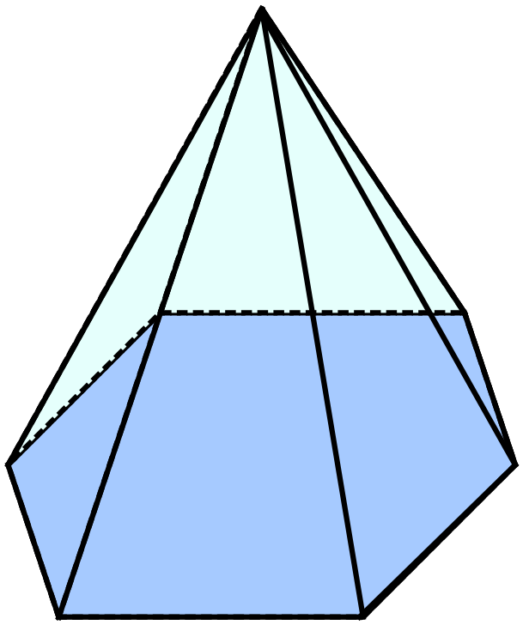What name could be given to the solid below?

Hexagonal prism
Hexagonal pyramid
Octagonal prism.
Octagonal pyramid.

What name would be given to a solid whose net is shown below?
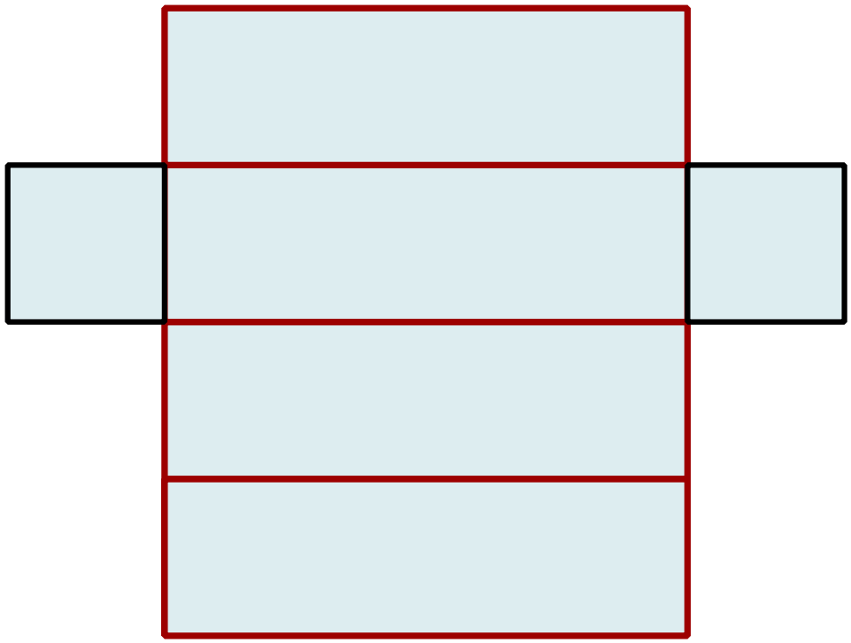

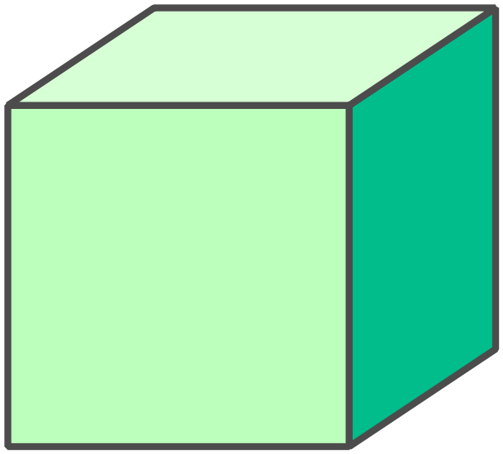A cube has a side length of 5 cm?
What is its volume?

25 cm³
50 cm³
125 cm³
250 cm³
What is the volume of the rectangular prism?
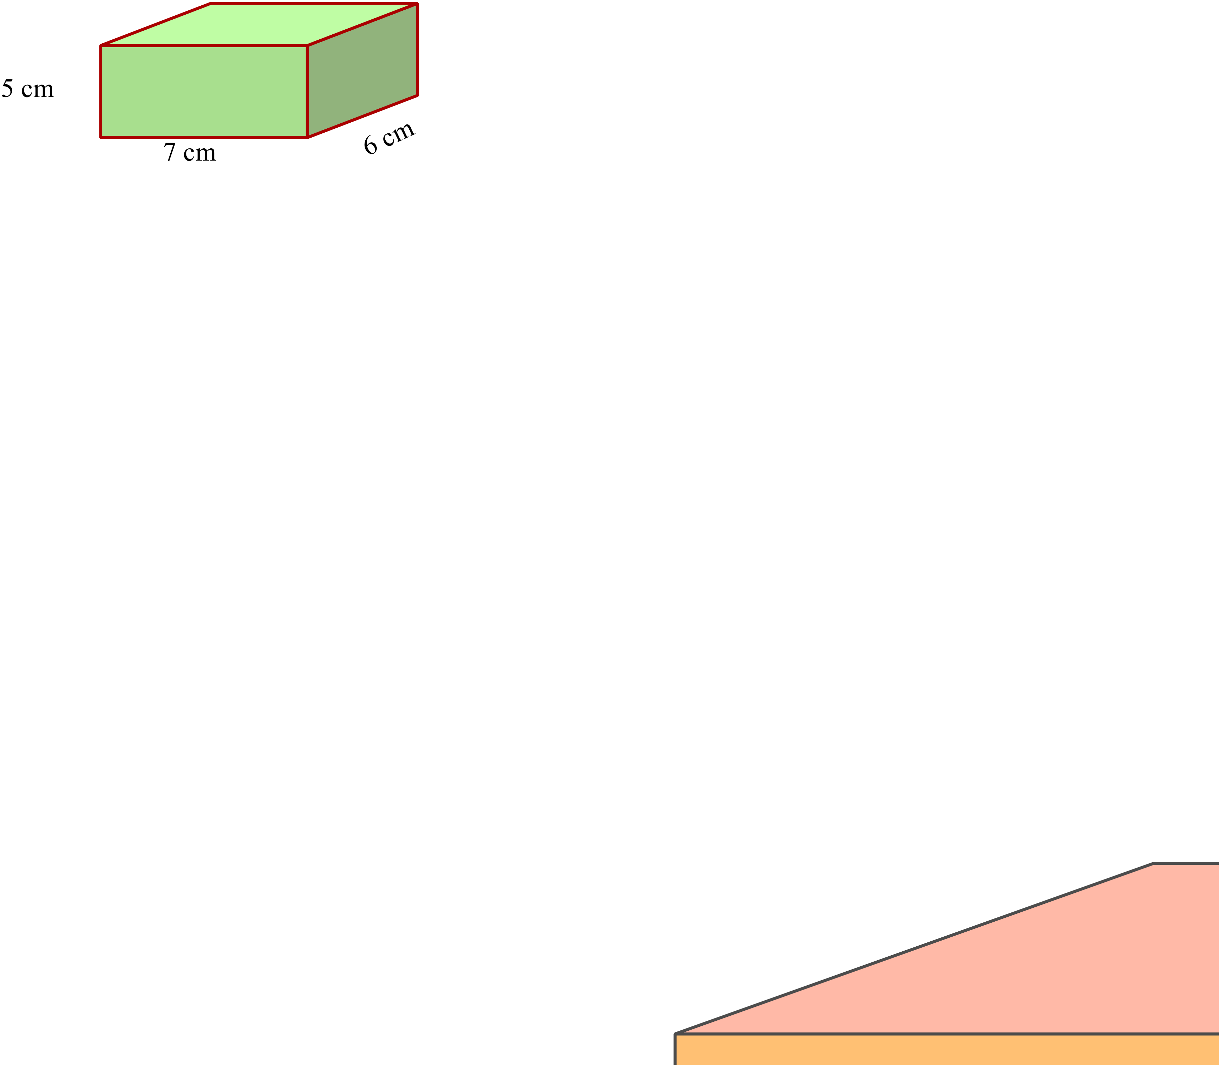

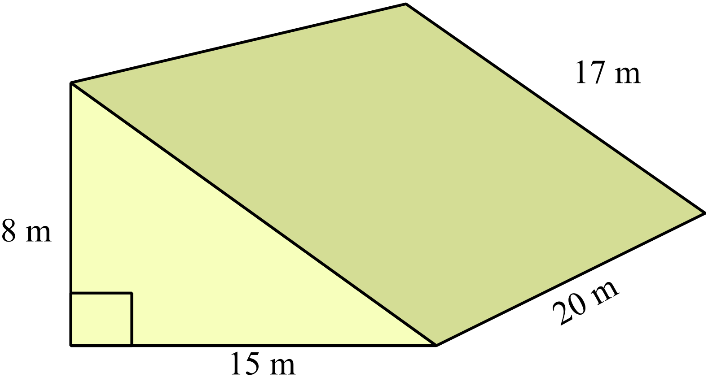Find the volume of the triangular prism shown.

240 cm³
920 cm³
1020 cm³
1200 cm³

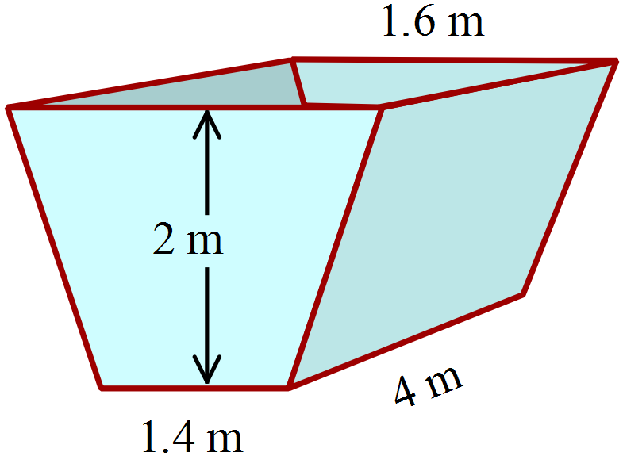A garbage skip bin is in the shape of a trapezoidal prism.
It is 2 m deep and 4 m long. It is 1.6 m wide at the top and 1.4 m wide at the bottom
What is its volume in cubic metres?

12 m³
18 m³
24 m³
36 m³
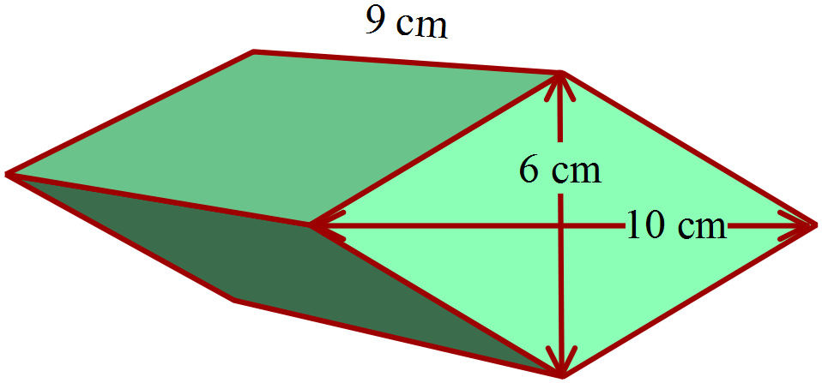The prism has a rhombus as its base.
What is its volume?

30 cm³
90 cm³
270 cm³
540 cm³
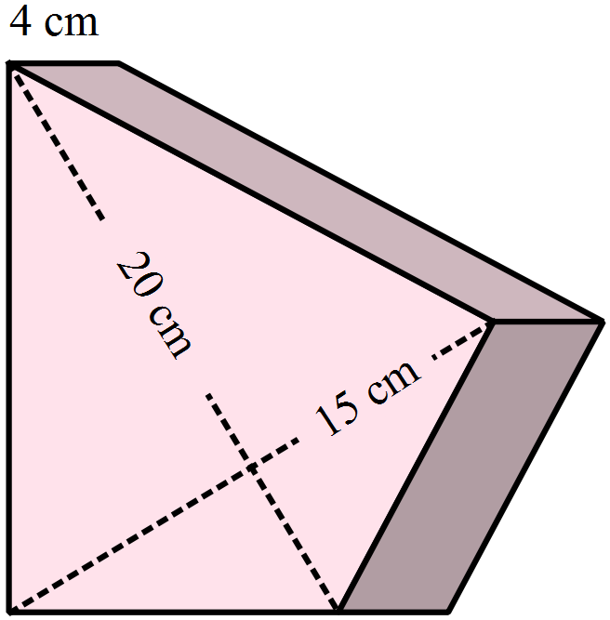A trophy is a prism with a kite as its cross-section with the dimensions shown.
What is its’ volume?

300 cm³
600 cm³
750 cm³
1 200 cm³

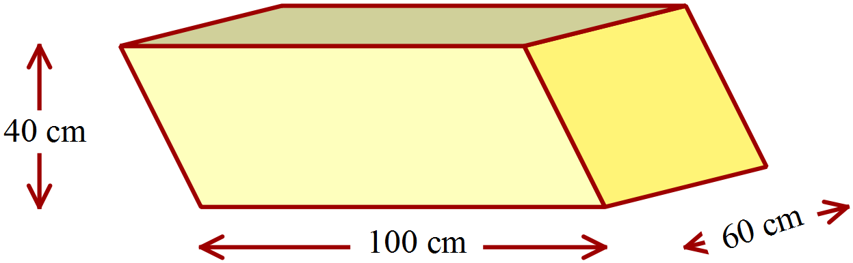A prism is shown, whose cross-section is a parallelogram.
What is the volume of the prism?

What is the volume of the solid shown?
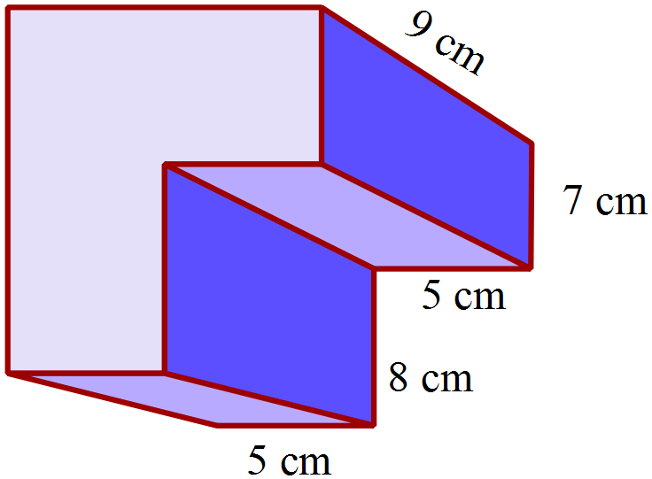

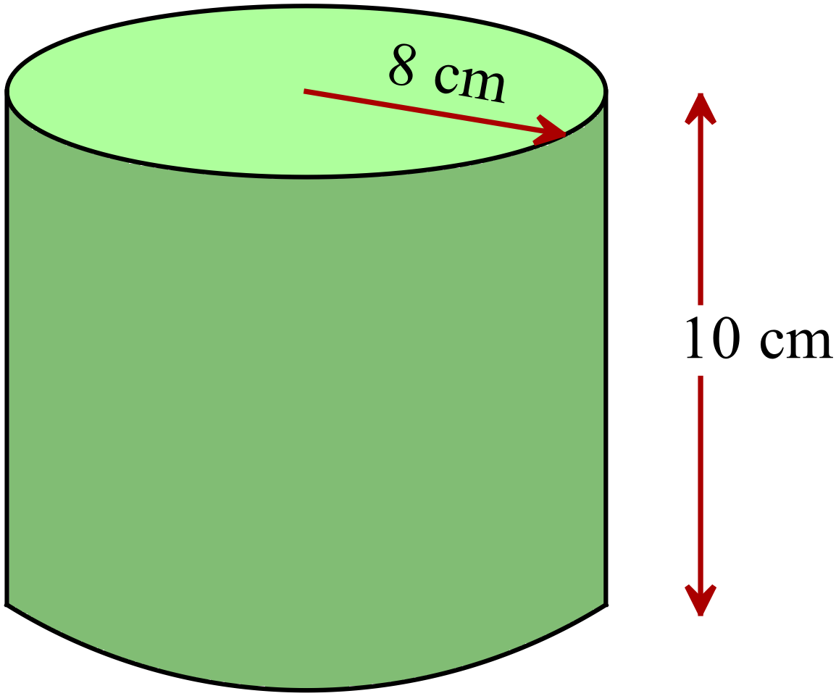What is the volume of the cylinder in terms of 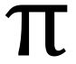 ?

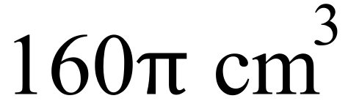
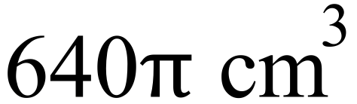
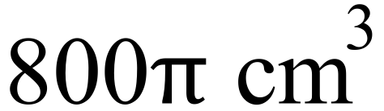
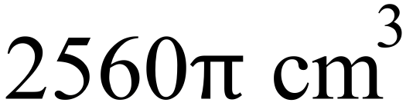

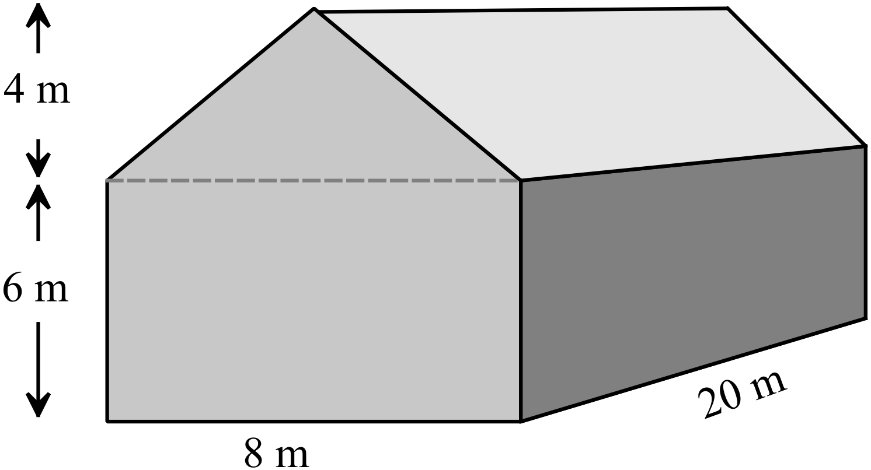A storage shed is shown at right.
Find the volume of the shed?

800 m³
960 m³
1280 m³
1600 m³
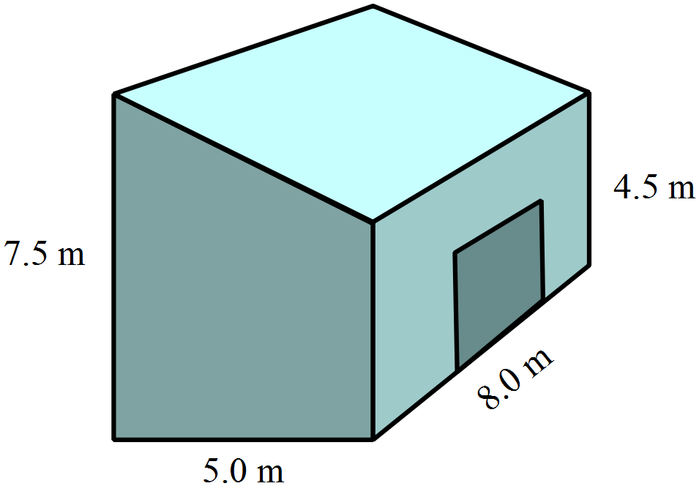A building has the dimensions shown.
What is its volume?

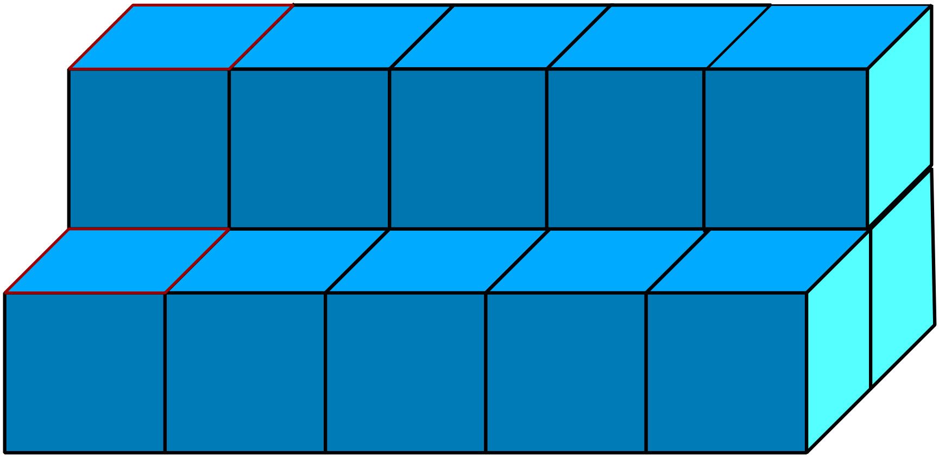A prism is made up of cubes which have 2 cm edges, as shown.
What is the volume of the prism?

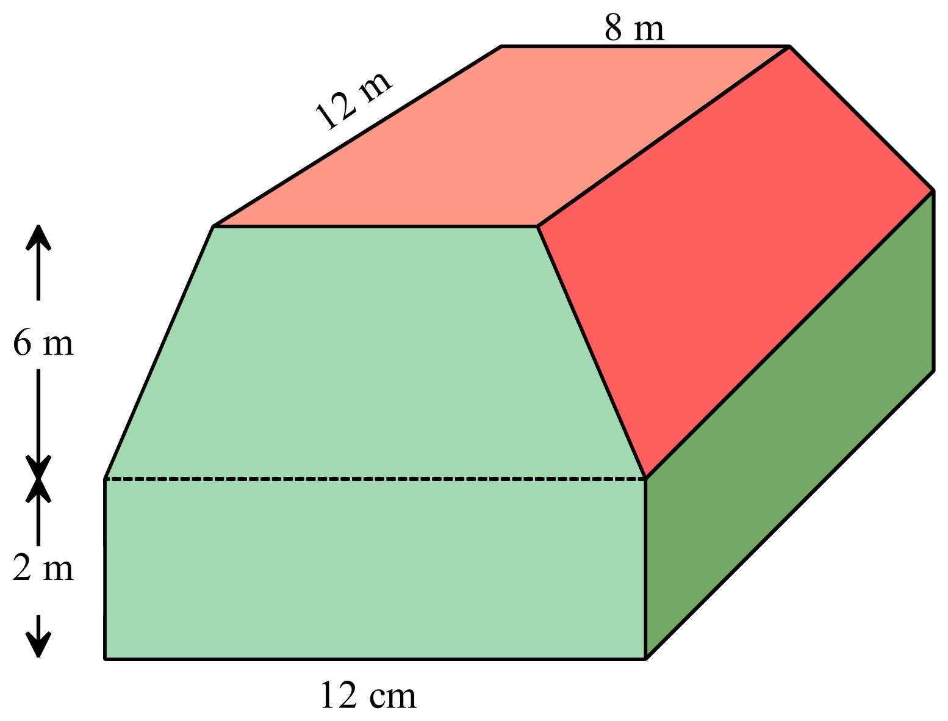A food package is in the form of a trapezoidal prism on top of a rectangular prism.
The dimensions are shown.
Find the volume of the package.

School Name
Mathematics Test 2017
Year 8 |  | Volume | Calculator Allowed  Short Answer  Section
 |  |  | Name___________________
Answer all questions in the spaces provided on this test paper by:
Writing the answer in the box provided.
or
Shading in the bubble for the correct answer from the four choices provided.
Show any working out on this test paper. Calculators are allowed.
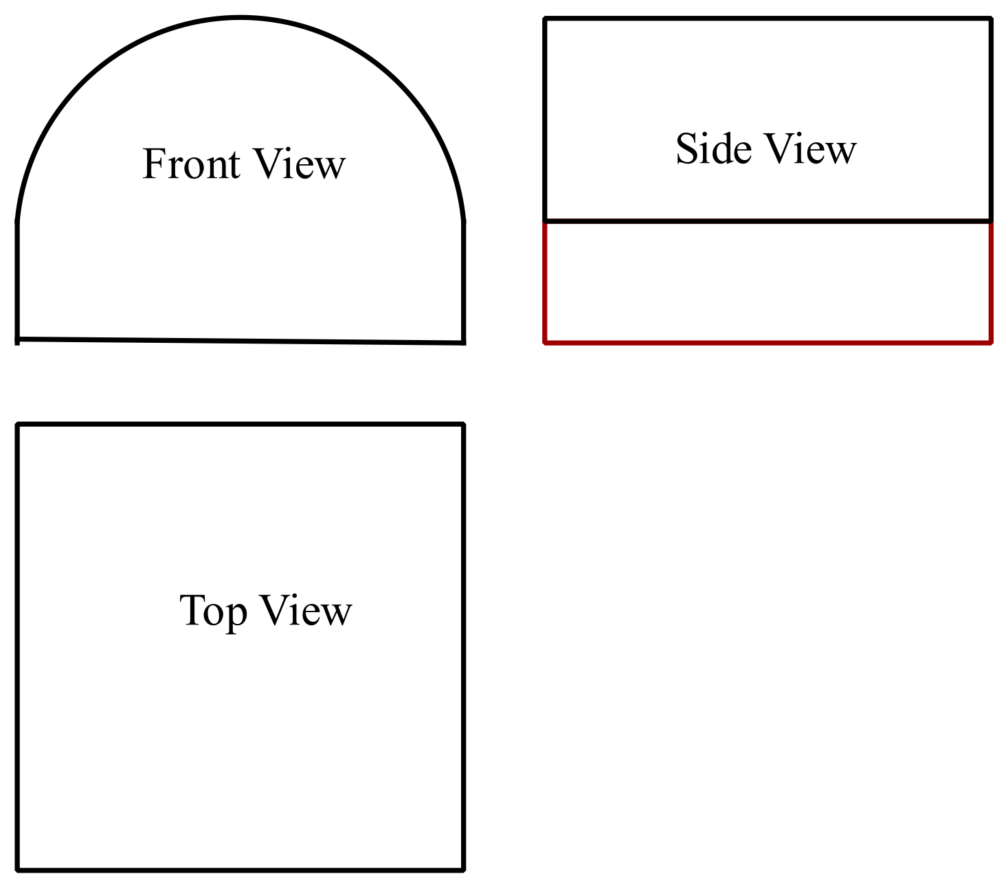Which diagram shows the three-dimensional view of the solid whose top and side views are shown below.

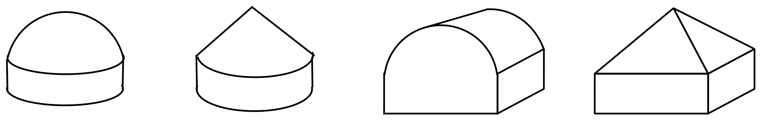

 | 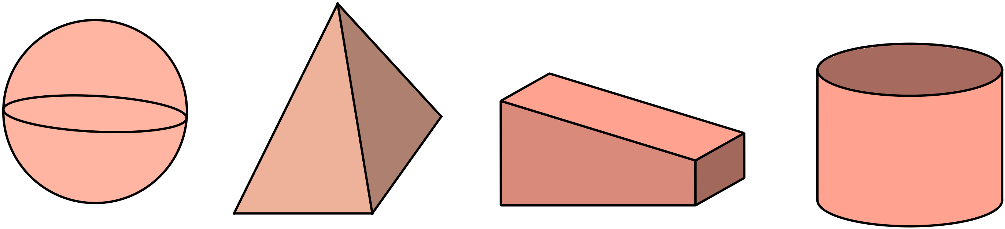Which solid below could be described as a pyramid?
What is the volume of the rectangular prism?
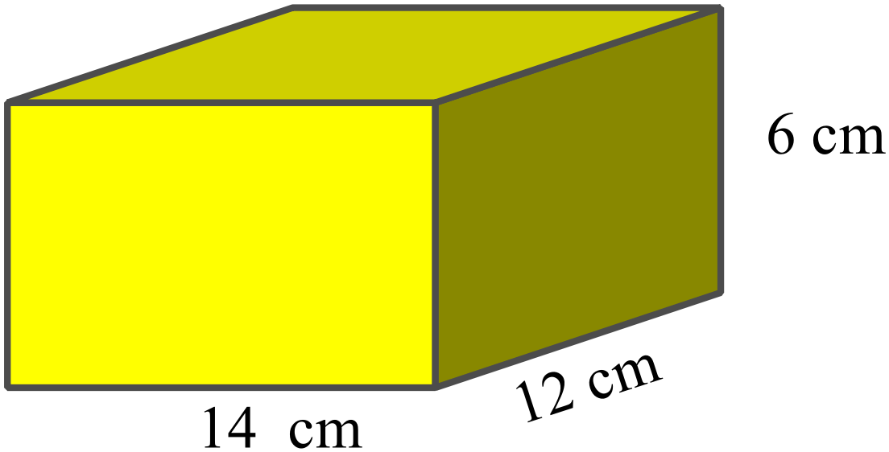

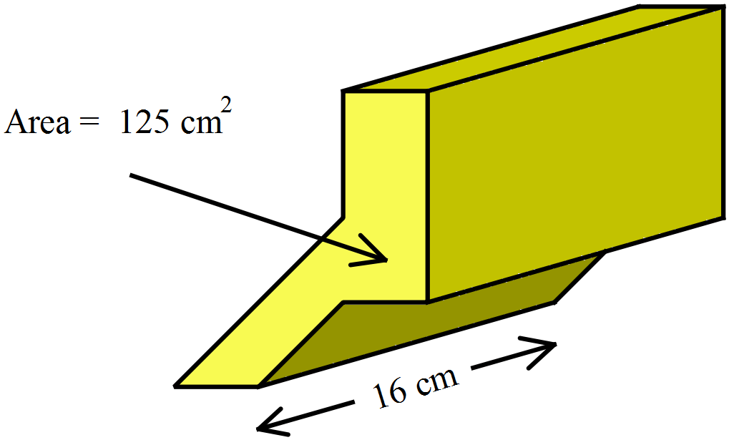The cross section of the prism shown is 125 cm².
What is the volume of the prism?

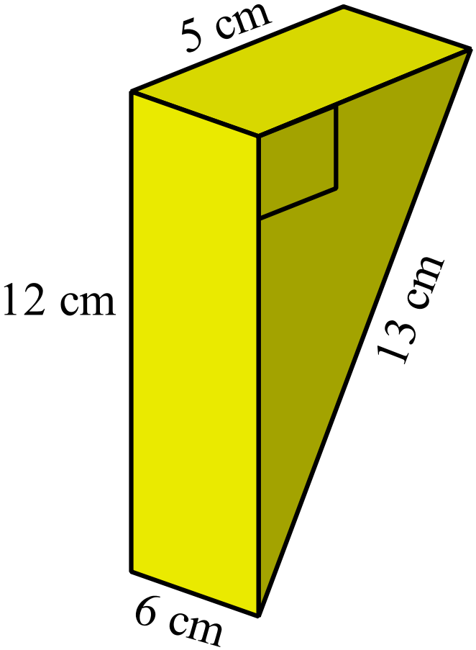What is the volume of the prism shown in cm³?

90 cm³
120 cm³
180 cm³
360 cm³

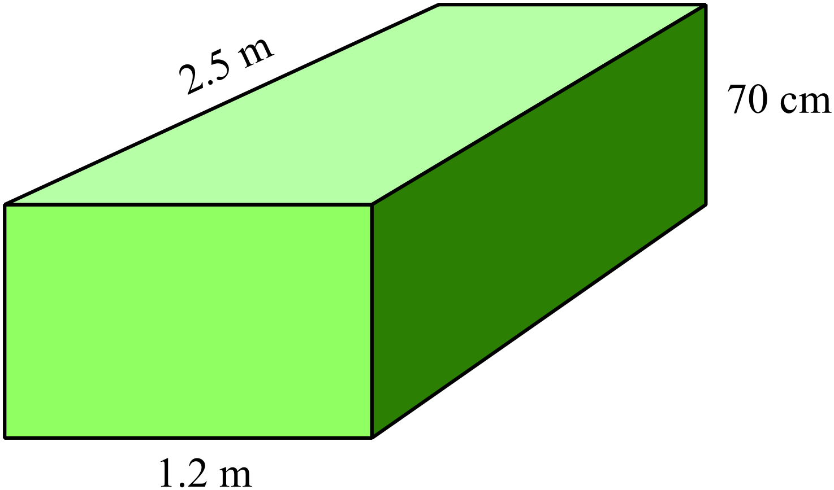What is the volume of the prism shown in m³?

2.1 m³
210 m³
21 000 m³
2 100 000 m³

 | 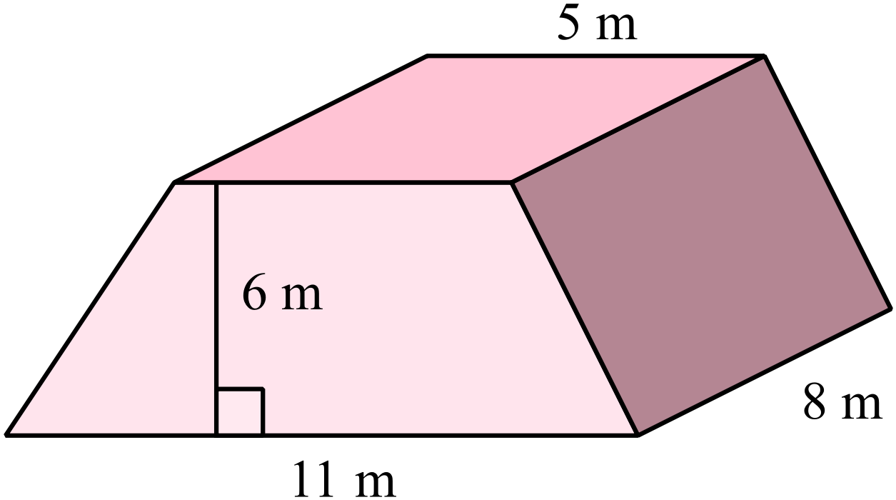Find the volume of the trapezoidal prism shown.
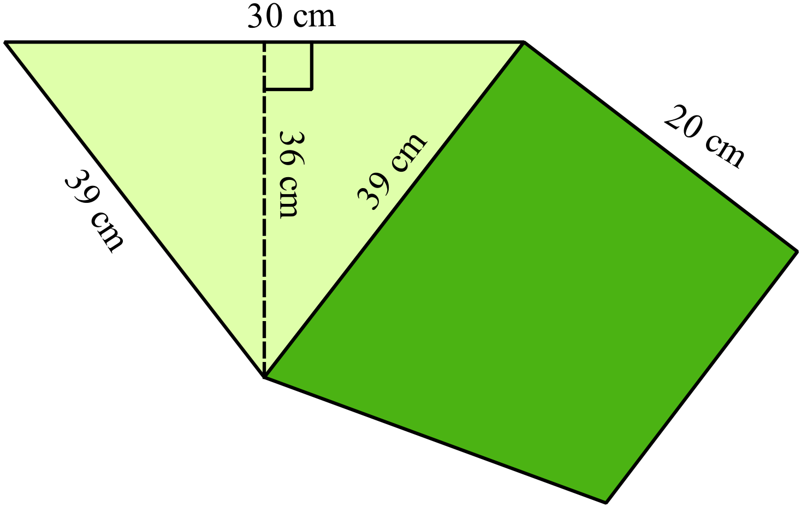What is the volume of the triangular prism shown?

5 400 cm³
10 800 cm³
11 700 cm³
21 600 cm³

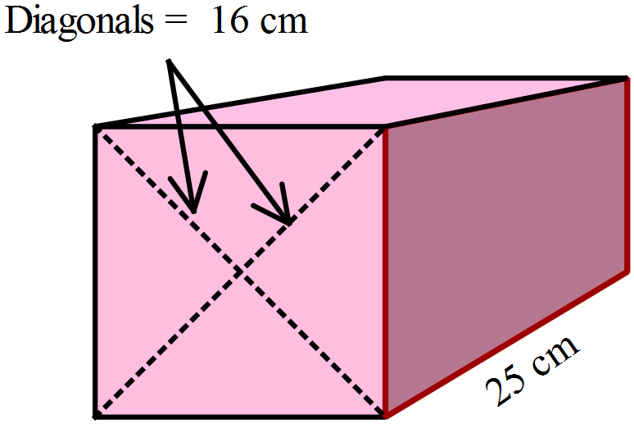Each diagonal of a square prism is 16 cm in length and the prism is 25 cm long.
What is the volume of the prism?
(Remember that a square is also a rhombus.)

What is the volume of the cylinder, correct to the nearest 100 mm³?
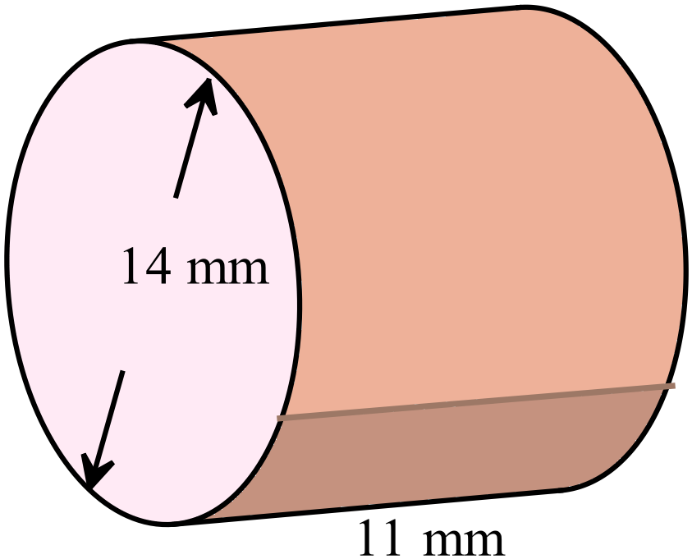
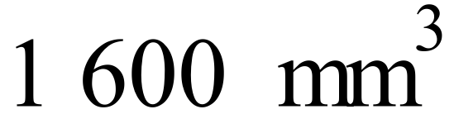
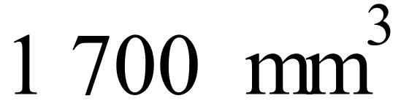
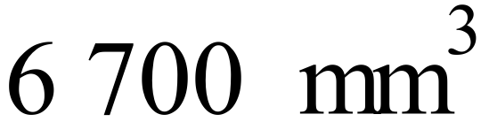
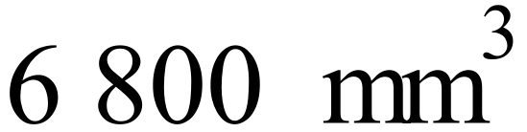

What is the volume of the rectangular prism whose net is shown here?
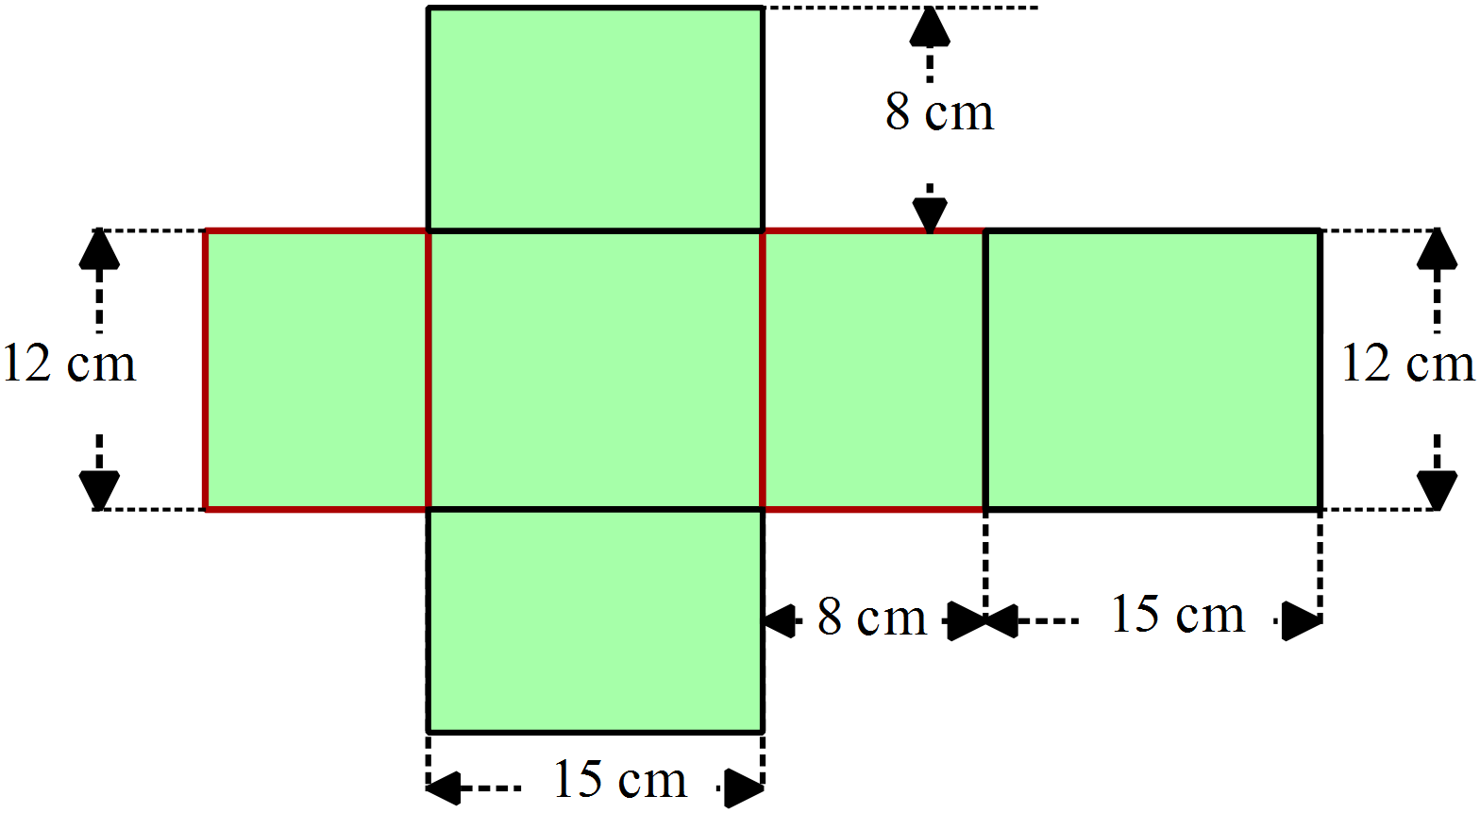

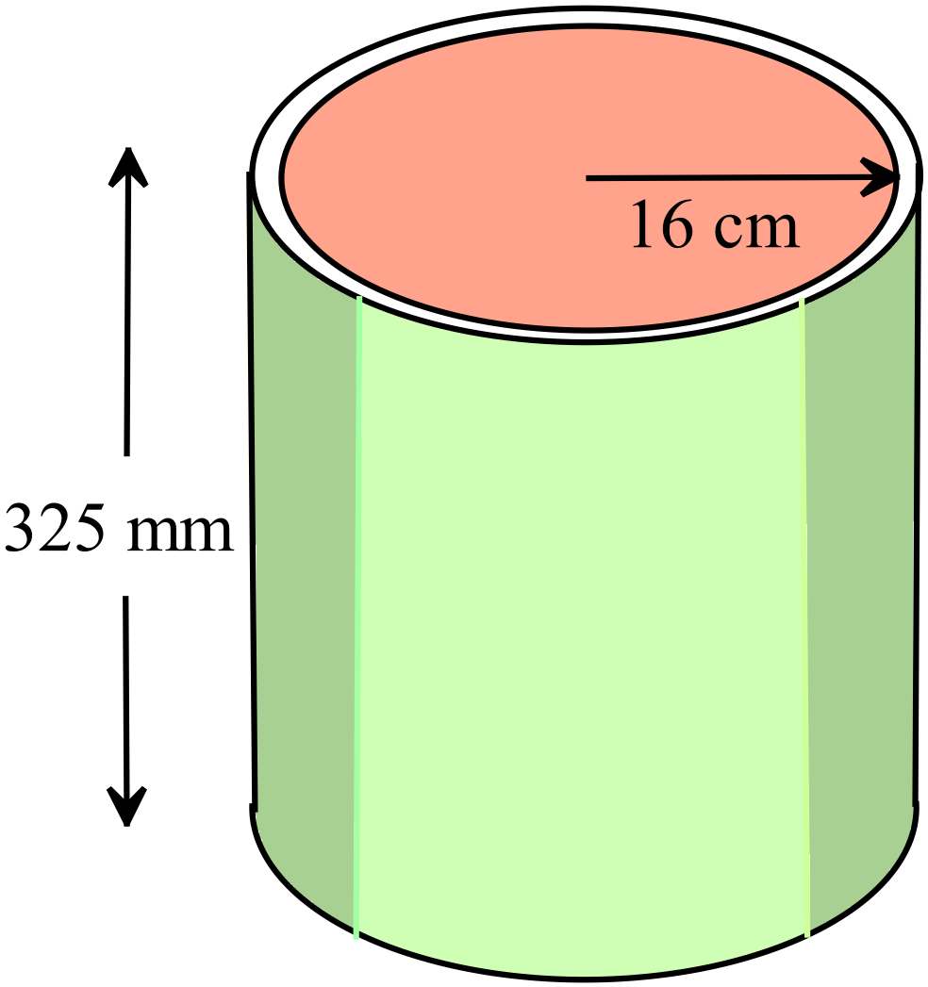What is the volume of this cylindrical tin?
Answer correct to the nearest cm³.

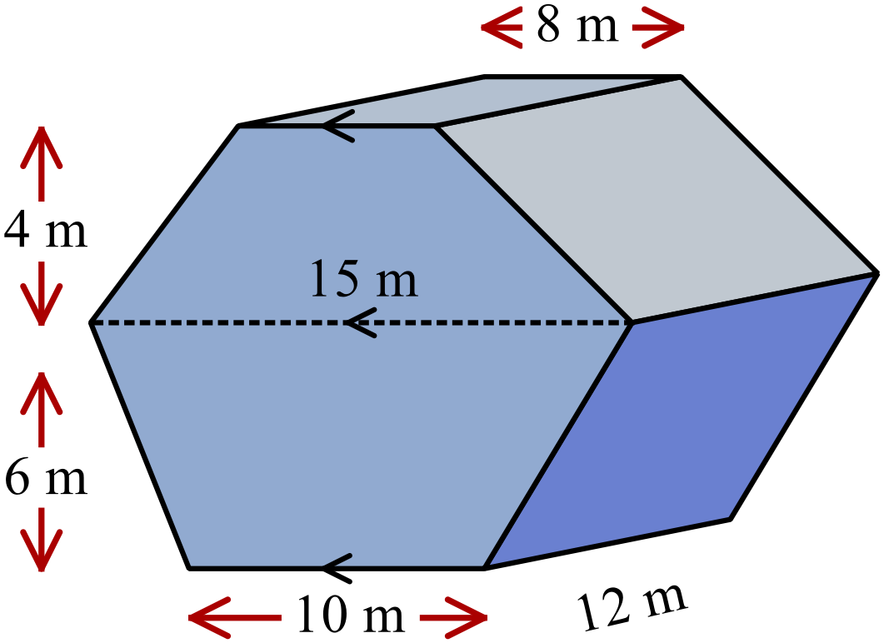An irregular hexagonal prism has the dimensions shown.
Calculate the volume of the prism in cubic metres.

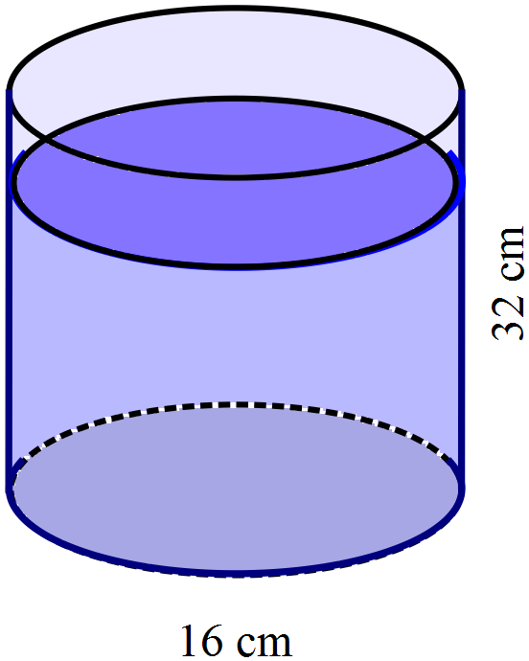A cylindrical container has a diameter of 16 cm and is 32 cm high.
It is currently three-quarters full of water.
Given that 1000 cm³ holds 1 litre, how many litres of water does the container currently hold? (to the nearest 10th of a litre.)

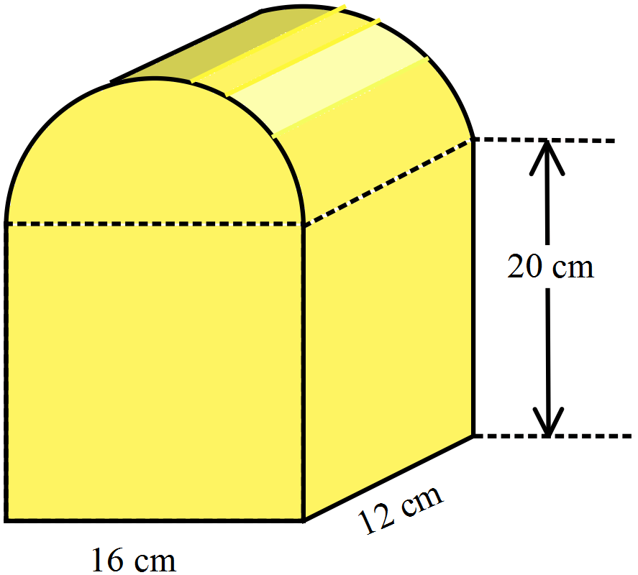The cross section of this prism is a semi-circle atop a rectangle.
Find the volume of the prism correct to the nearest cubic centimetre.

School Name
Mathematics Test 2017
Year 8 | Volume | Non Calculator Section
ANSWERS

Question | Working and Answer
 | It is a Hexagonal pyramid.
 | A square prism
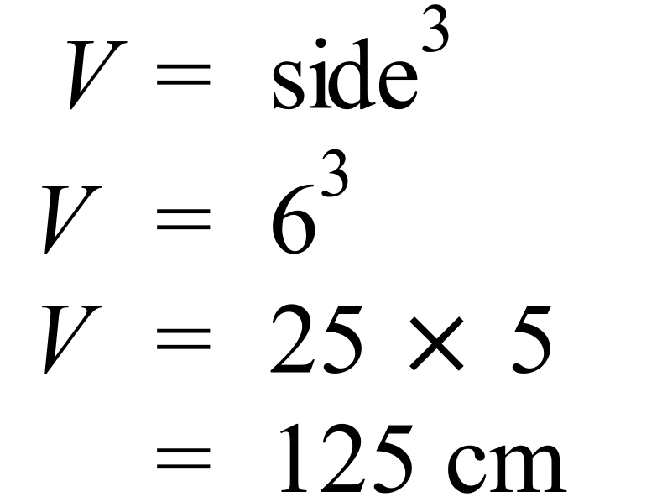
3rd Answer
 | 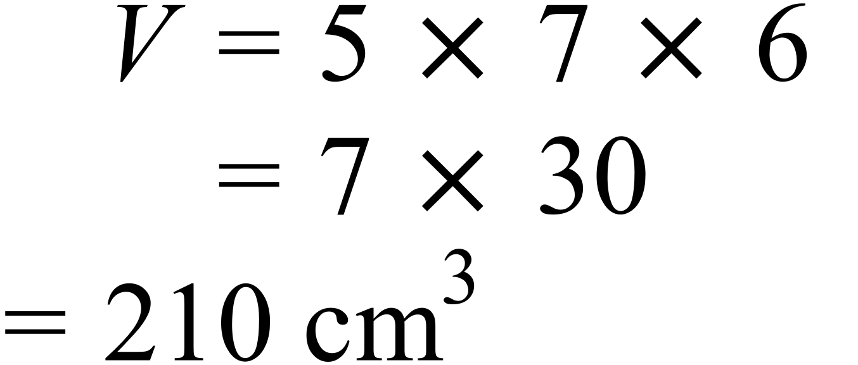
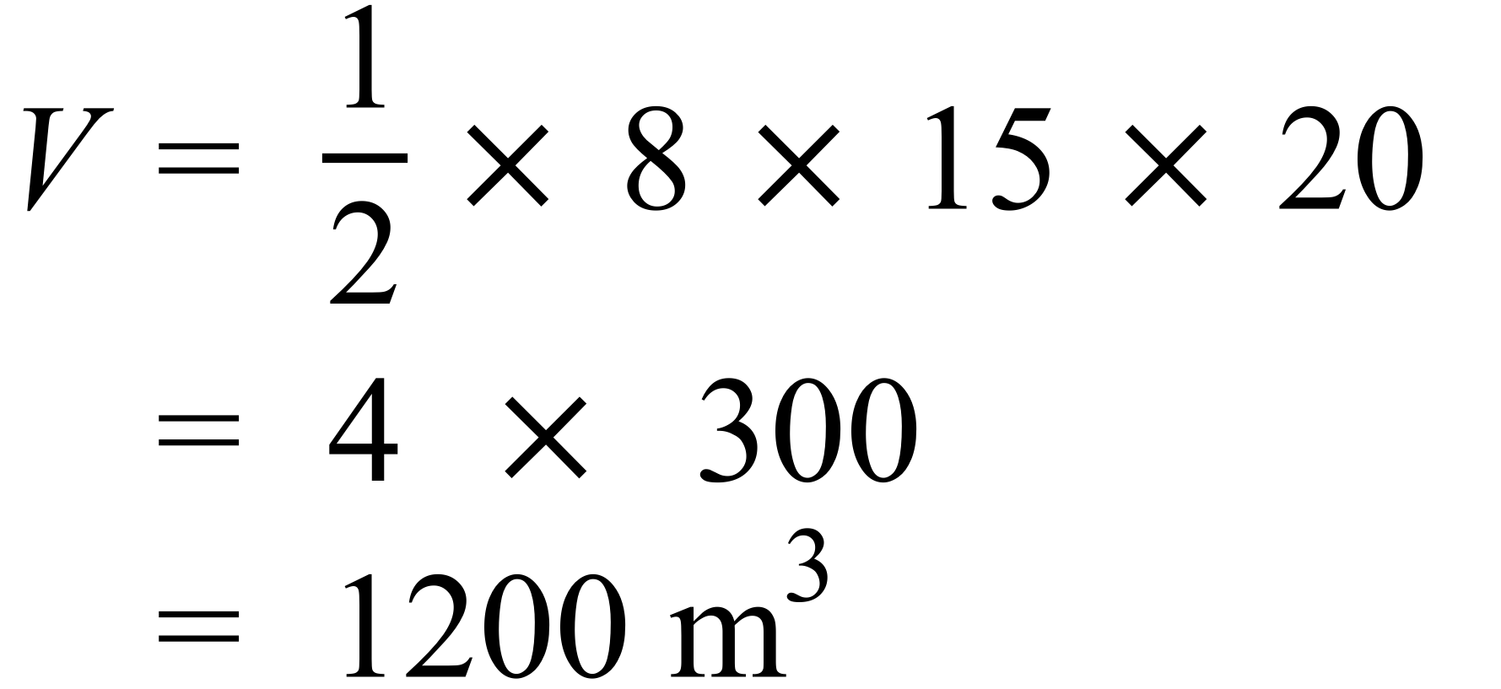
4th Answer
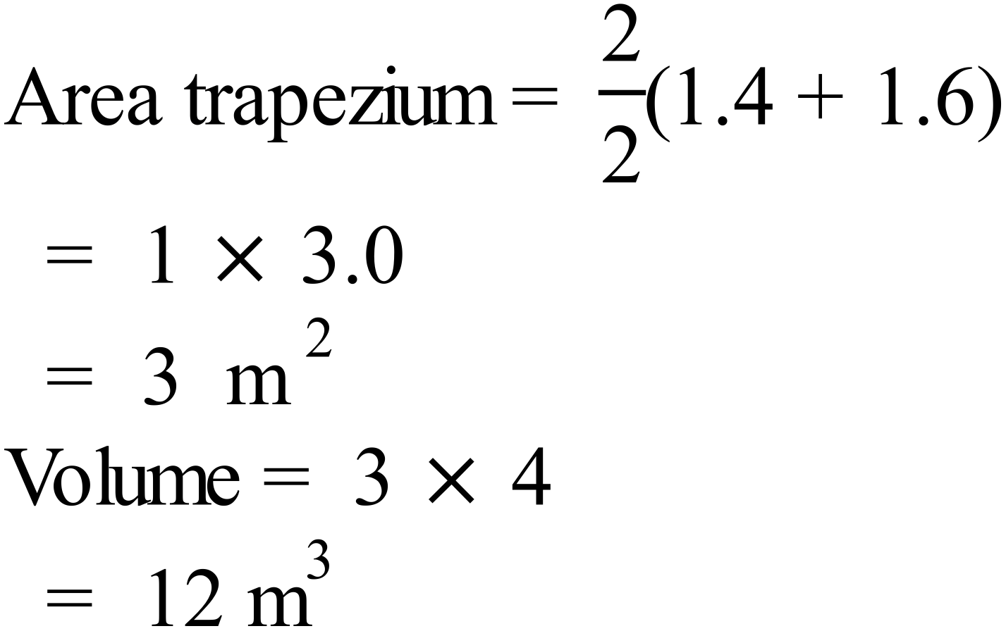
1st Answer
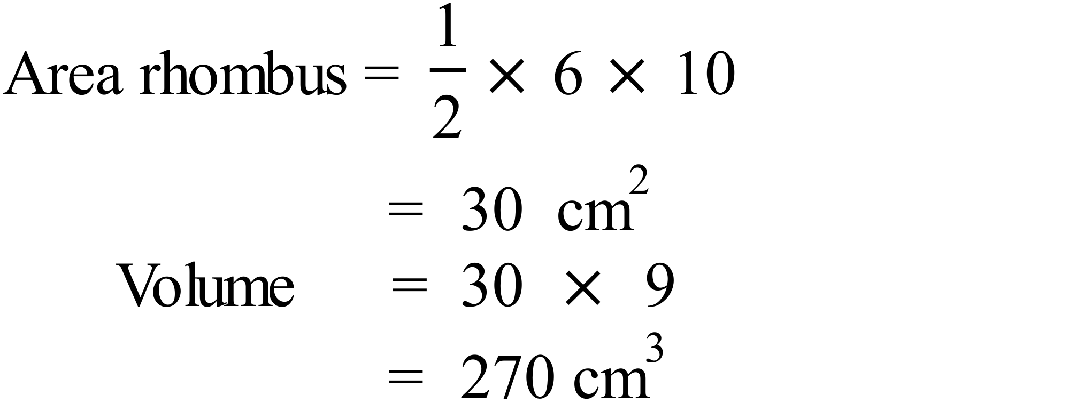
3rd Answer
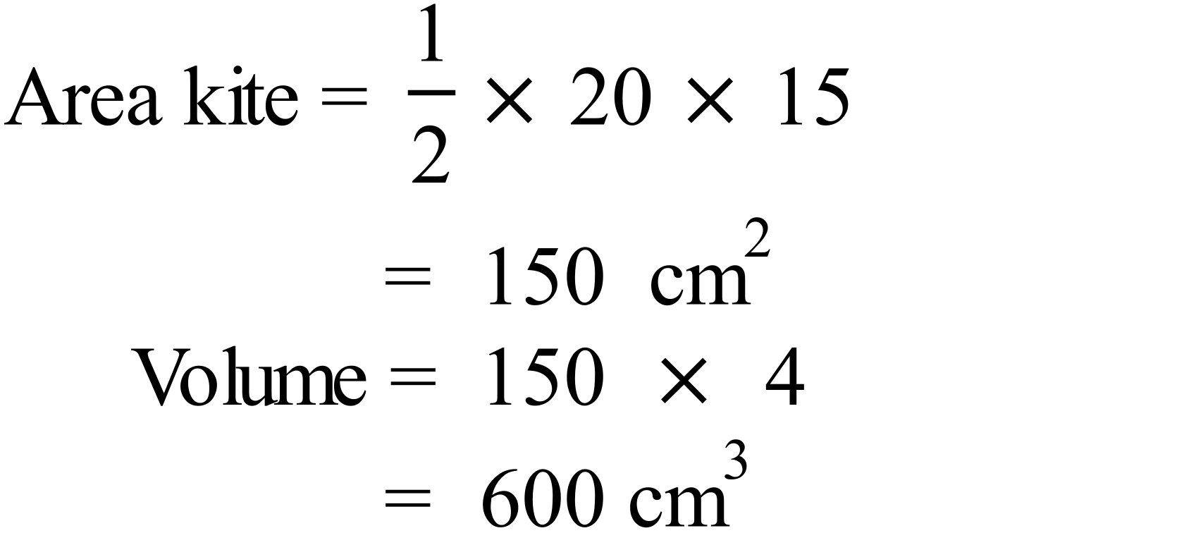
2nd Answer
 | 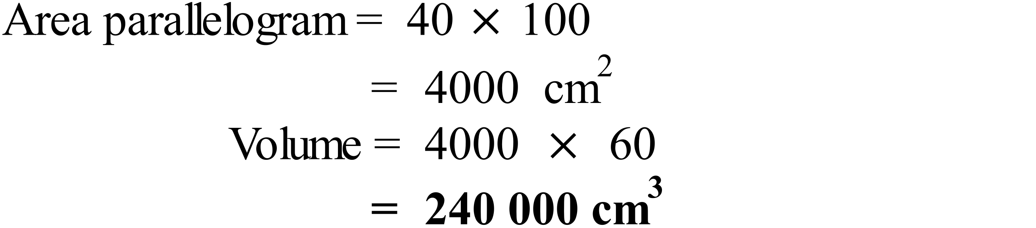
 | 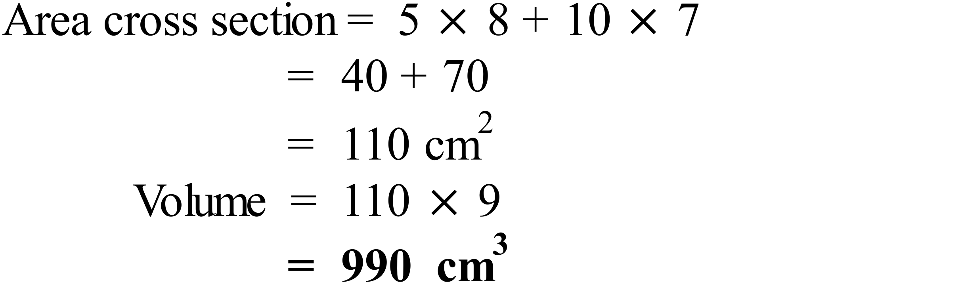
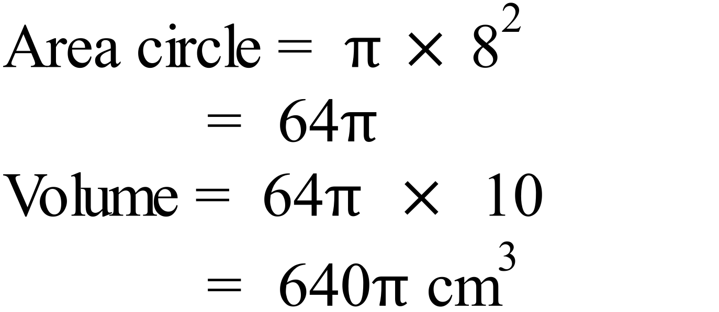
2nd Answer
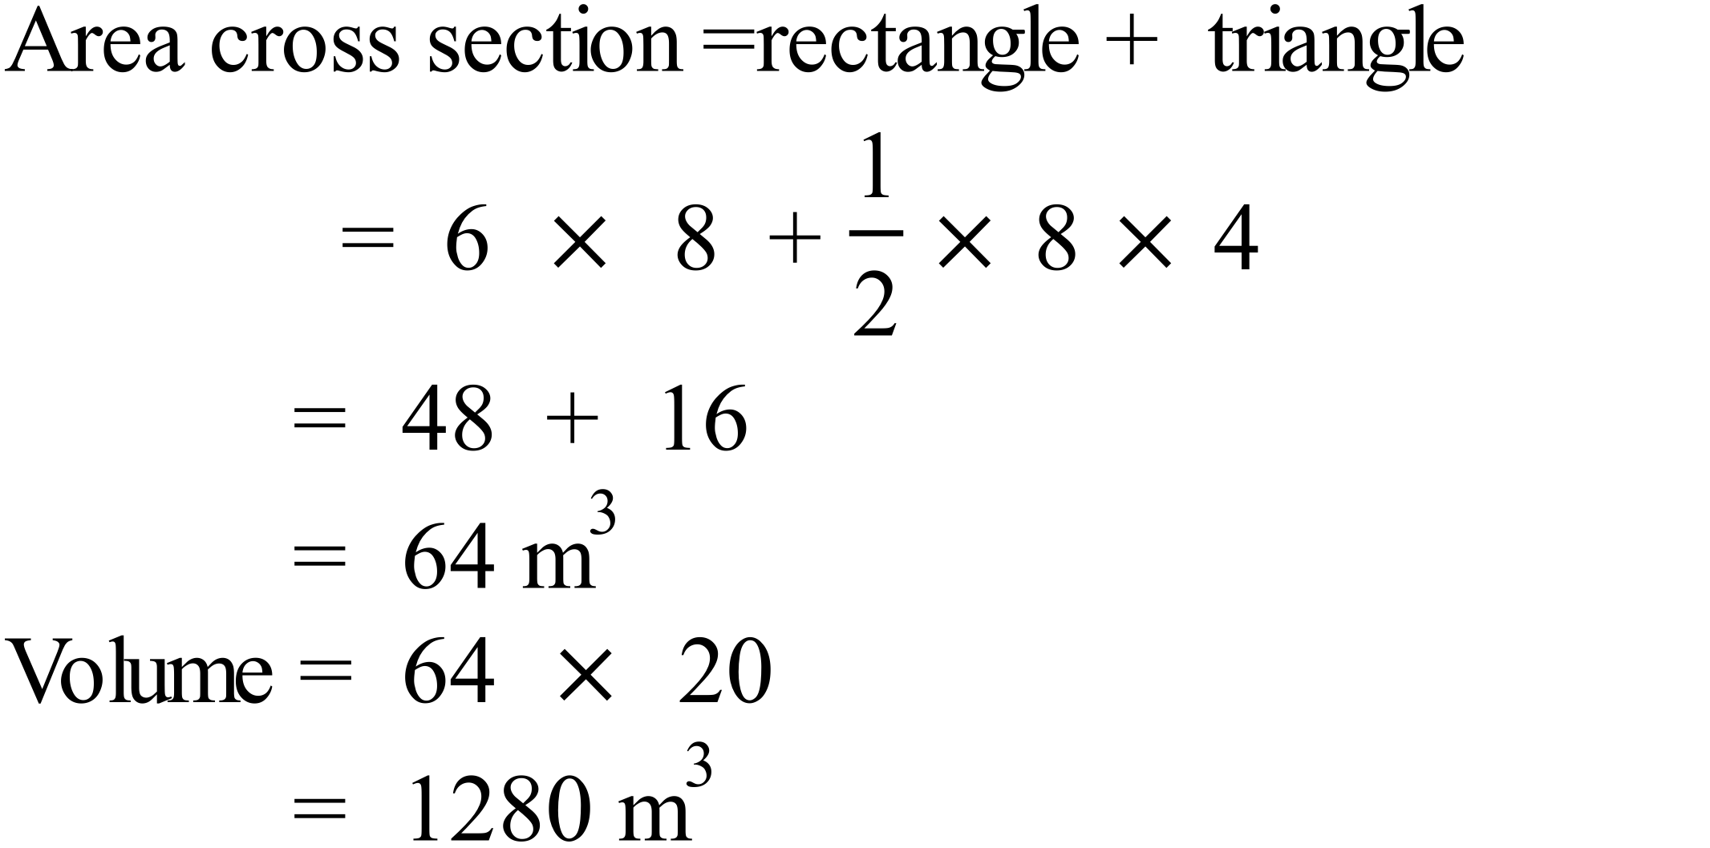
3rd Answer
 | 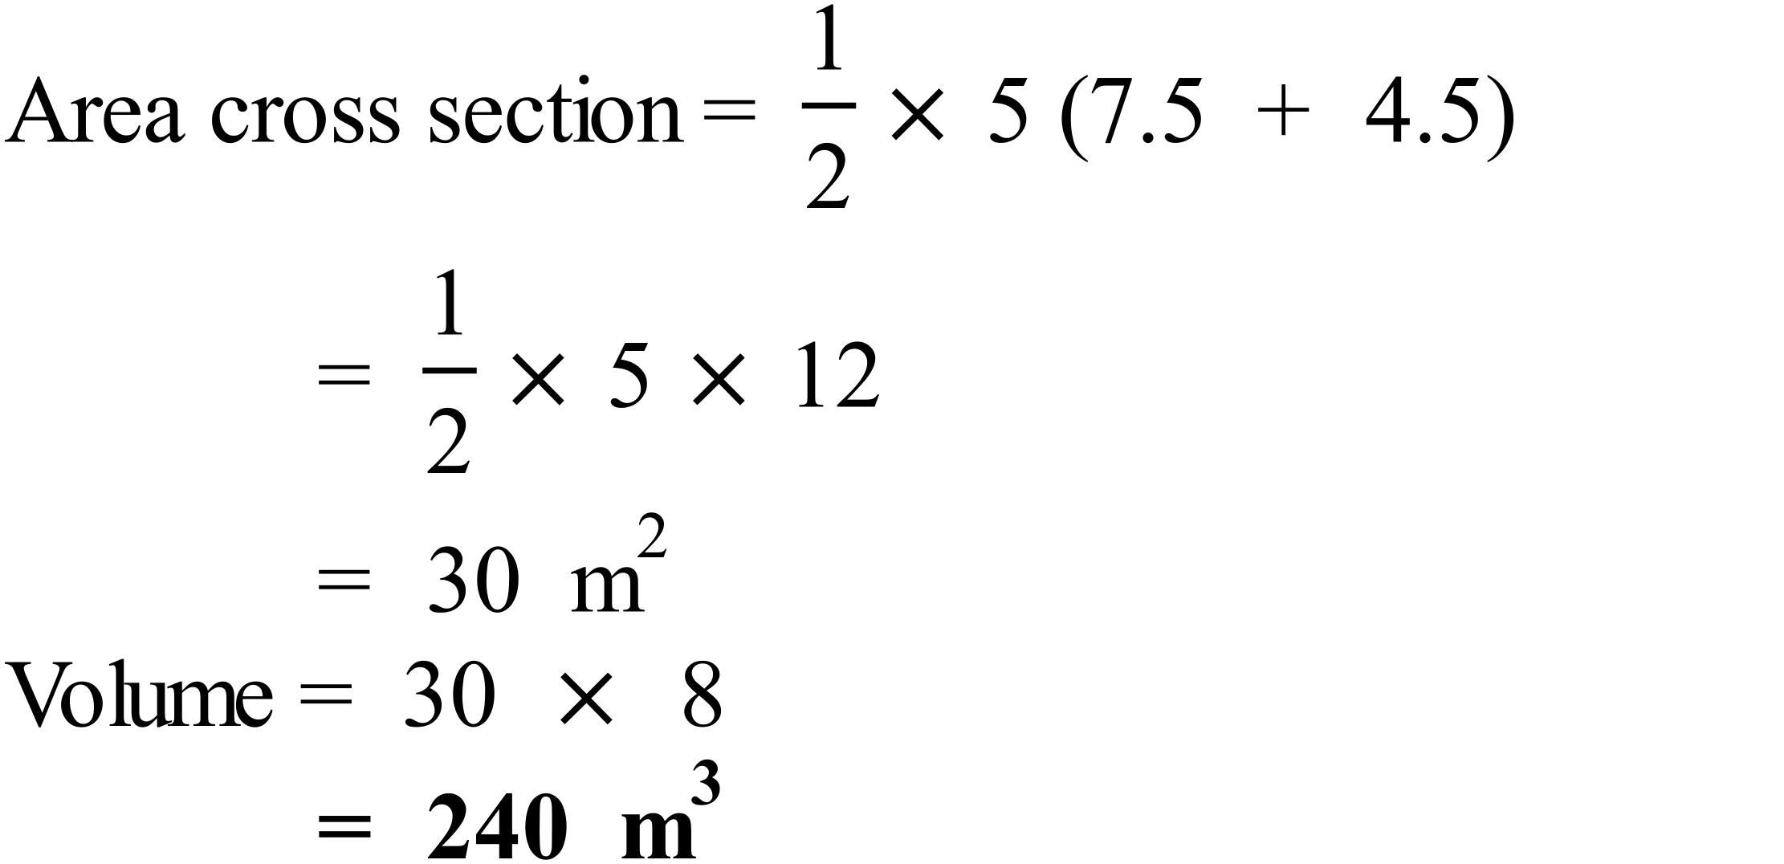
 | 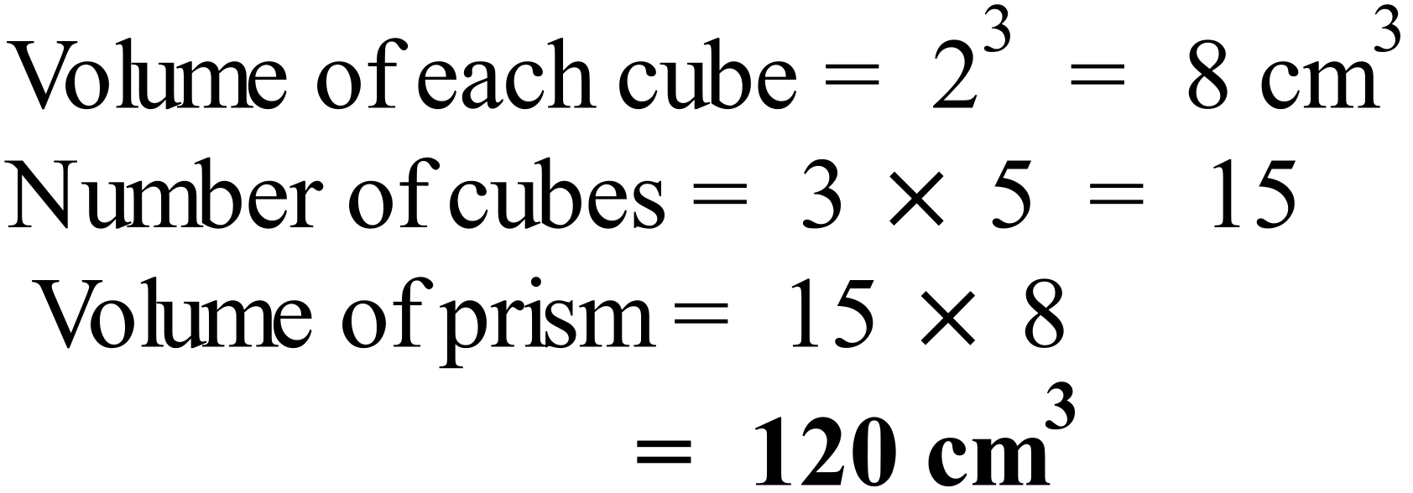
 | 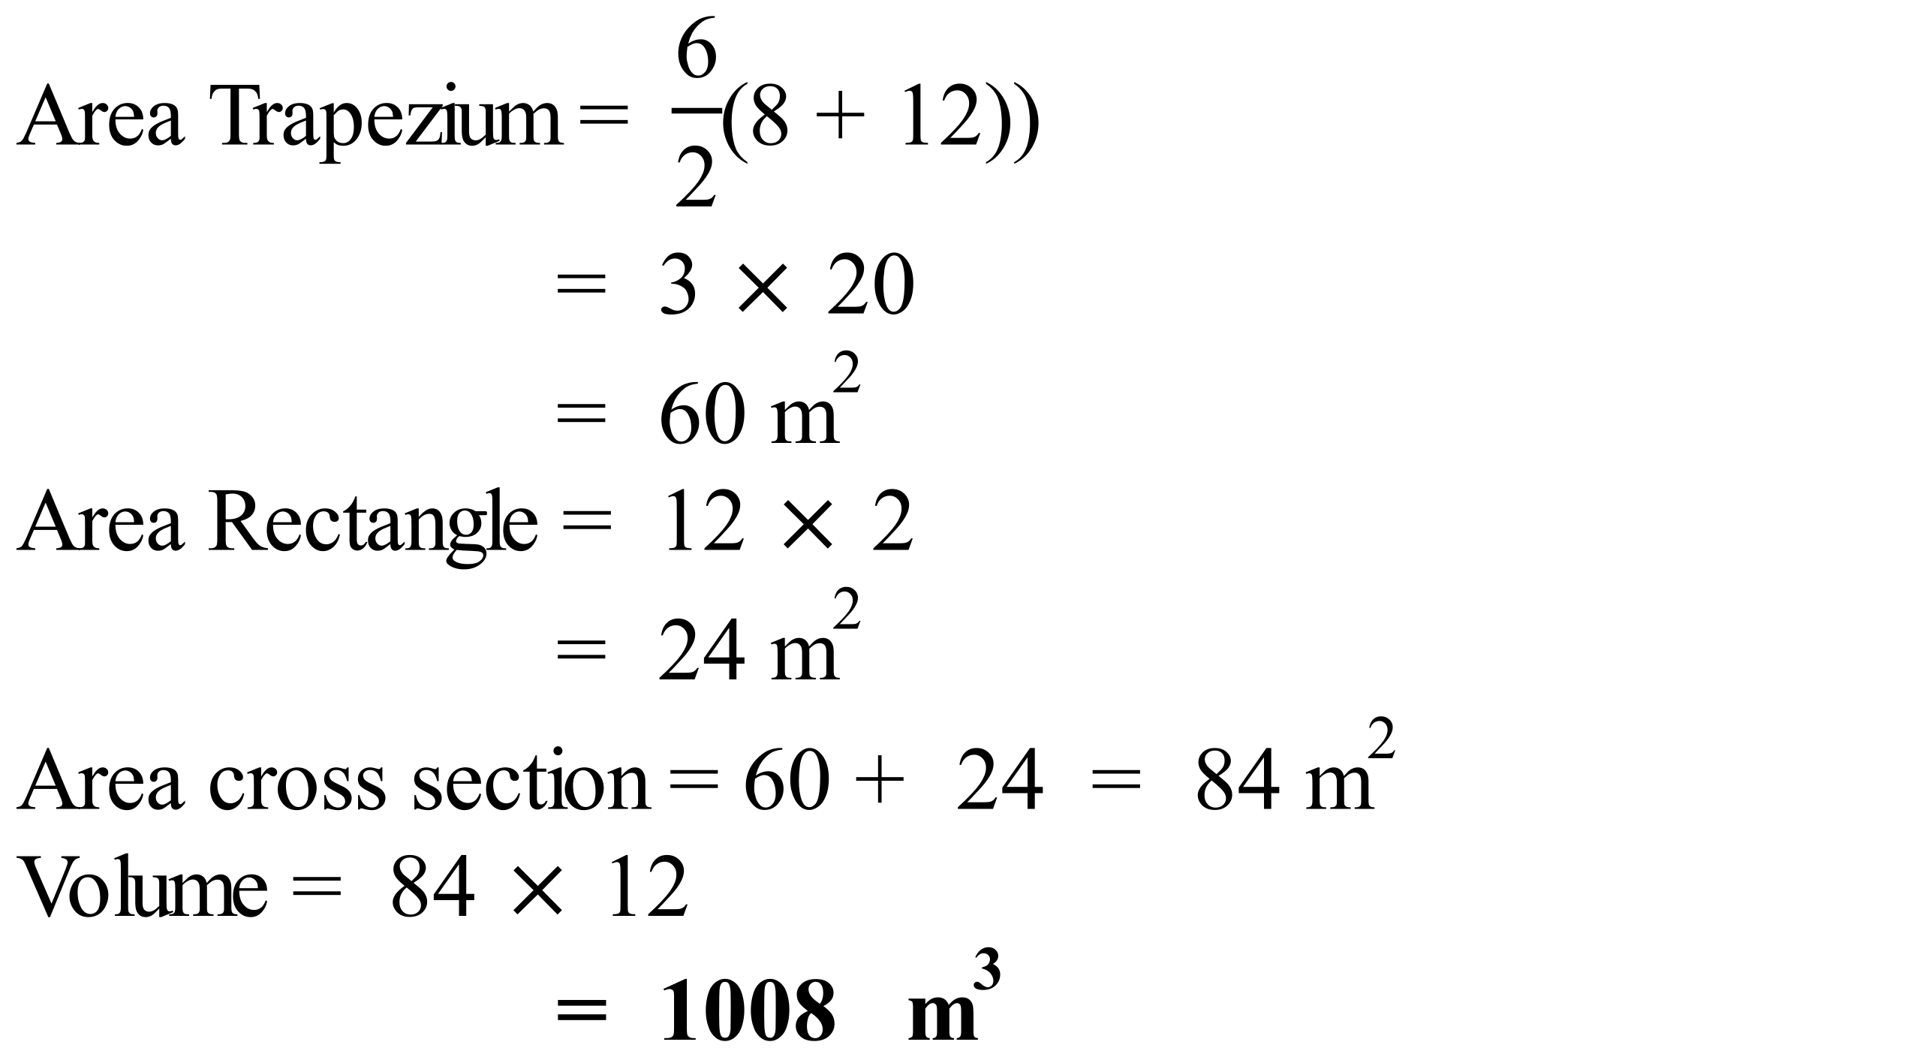

School Name
Mathematics Test 2017
Year 8 | Volume | Calculator Allowed  Short Answer  Section

ANSWERS
Question | Working and Answer
3rd shape has half of a cylinder on top of a rectangular prism, which from above appears as a rectangle and the side as two rectangles.
3rd Answer
Only the 2nd is a pyramid.
2nd Answer
 | 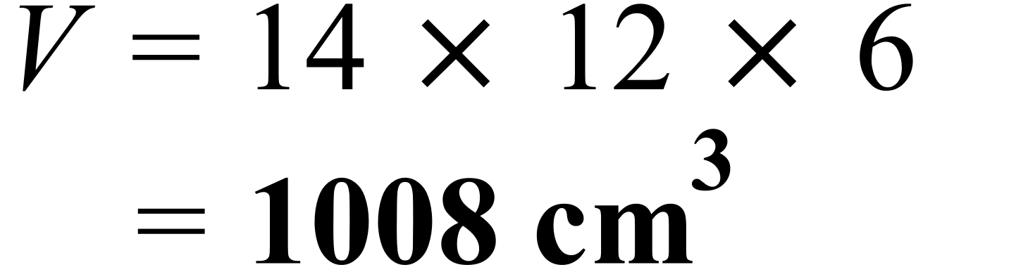
 | 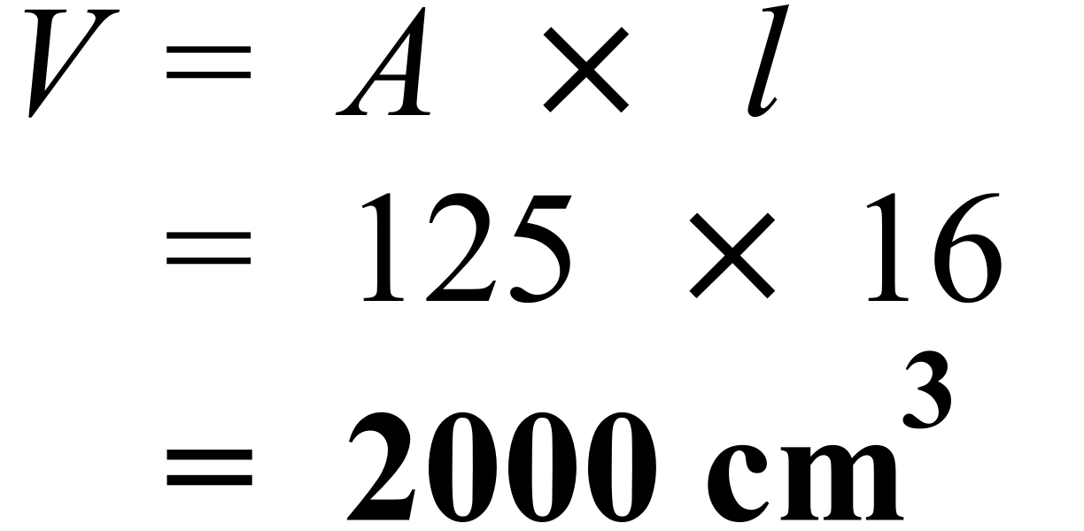
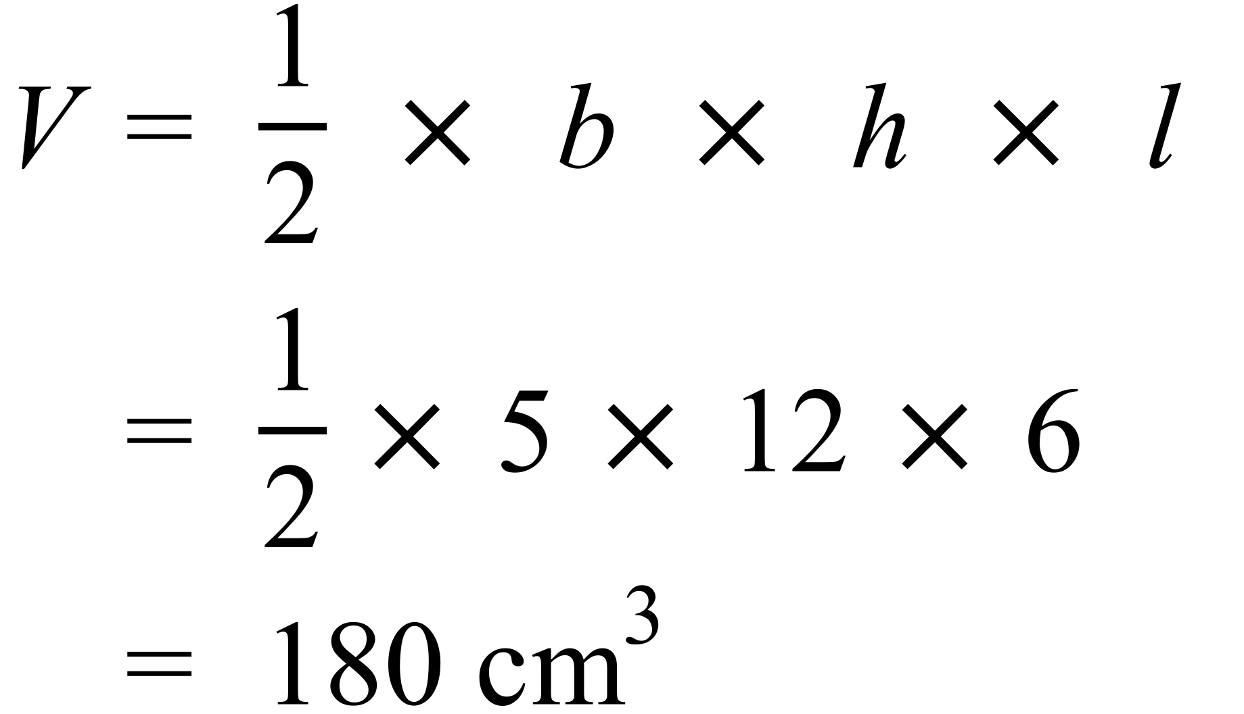
3rd Answer
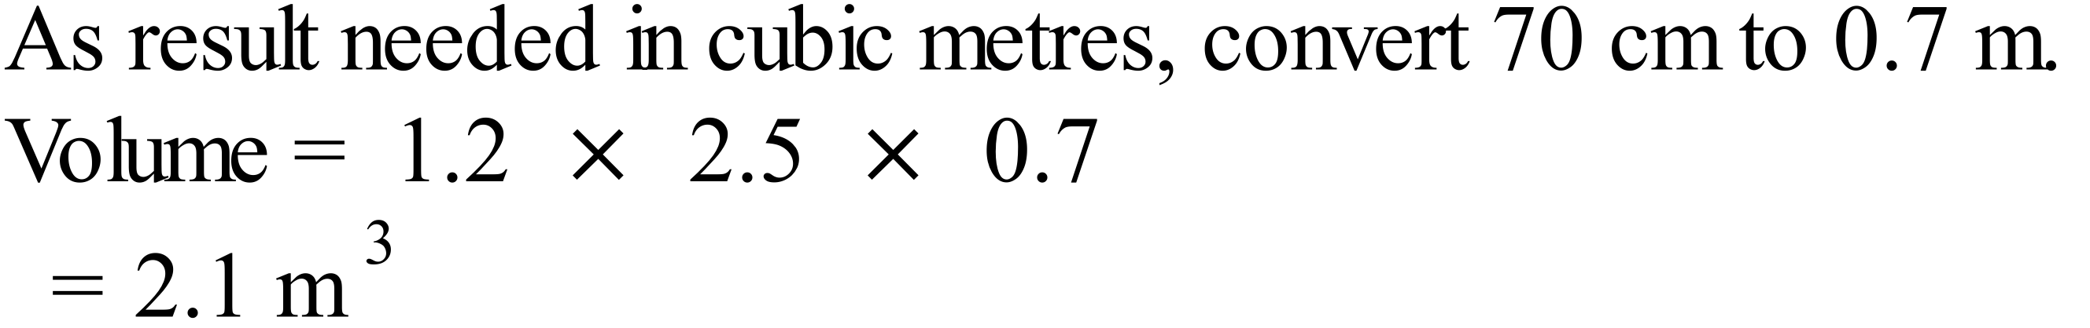
1st Answer
 | 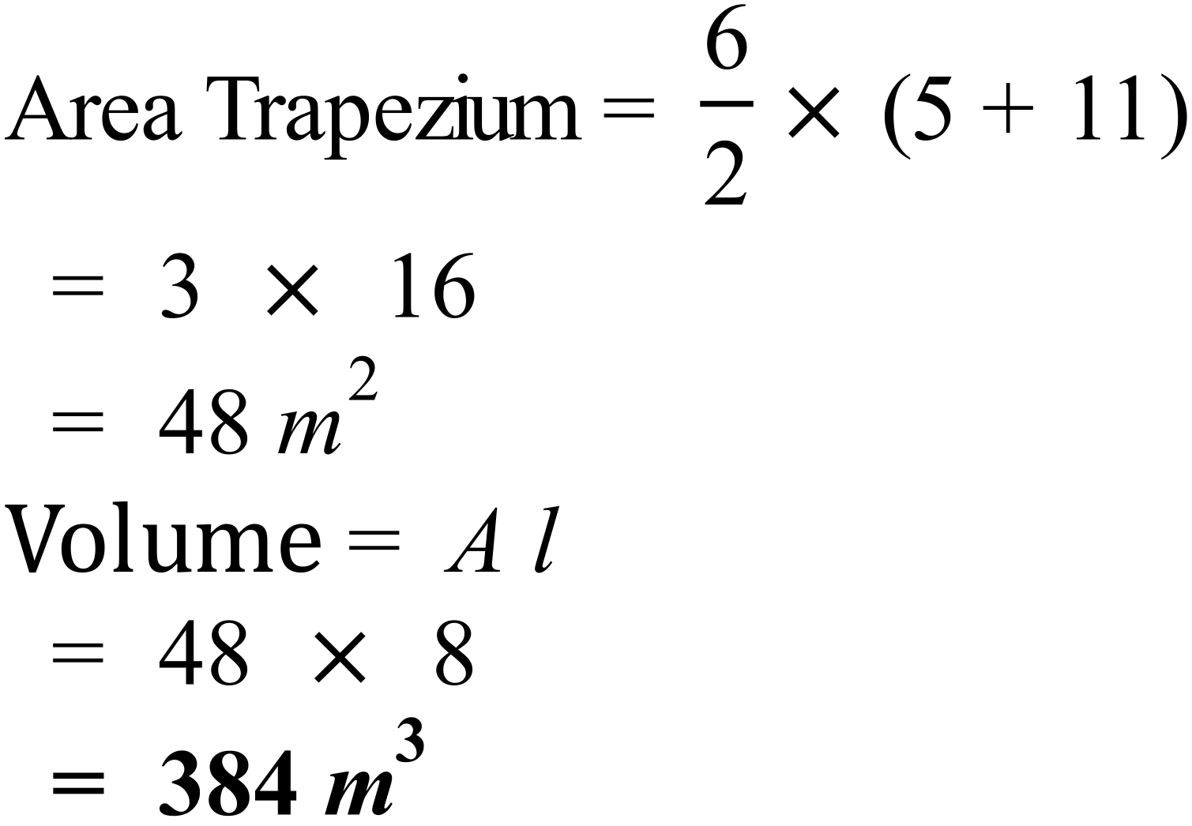
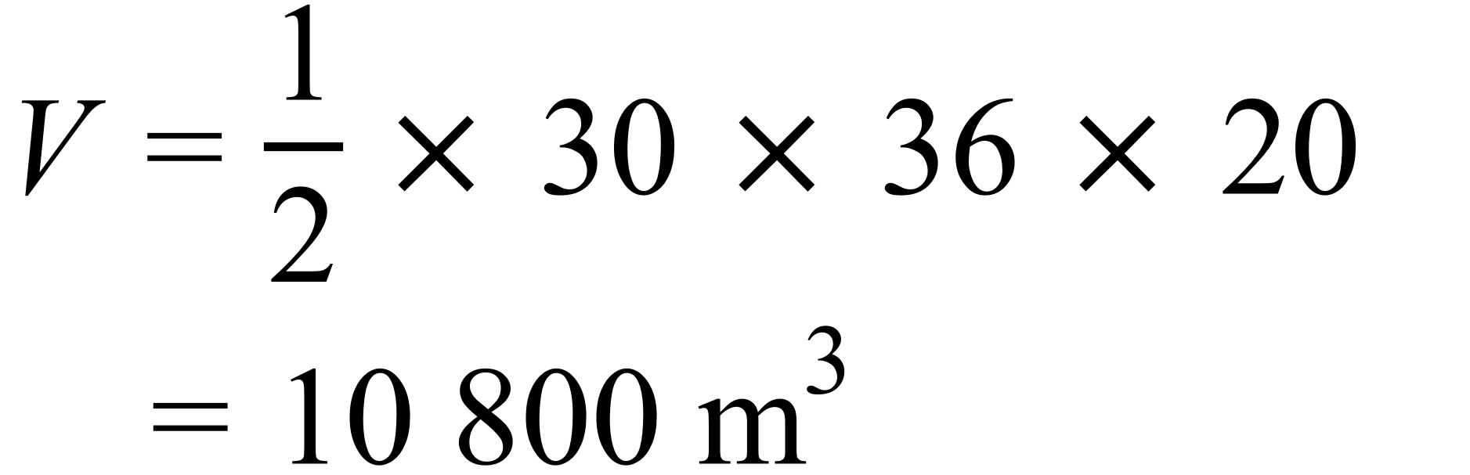
2nd Answer
 | 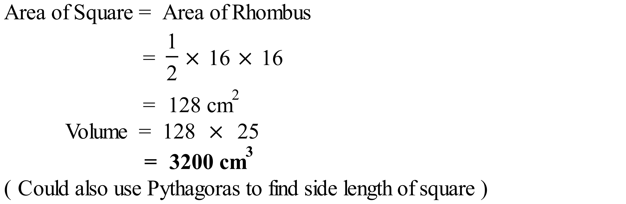
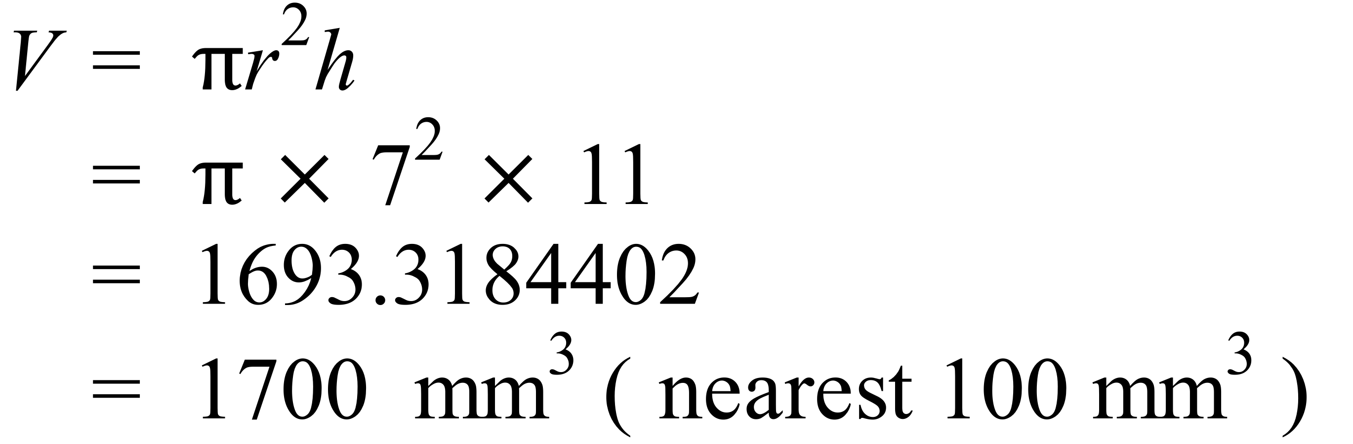
2nd Answer
 | 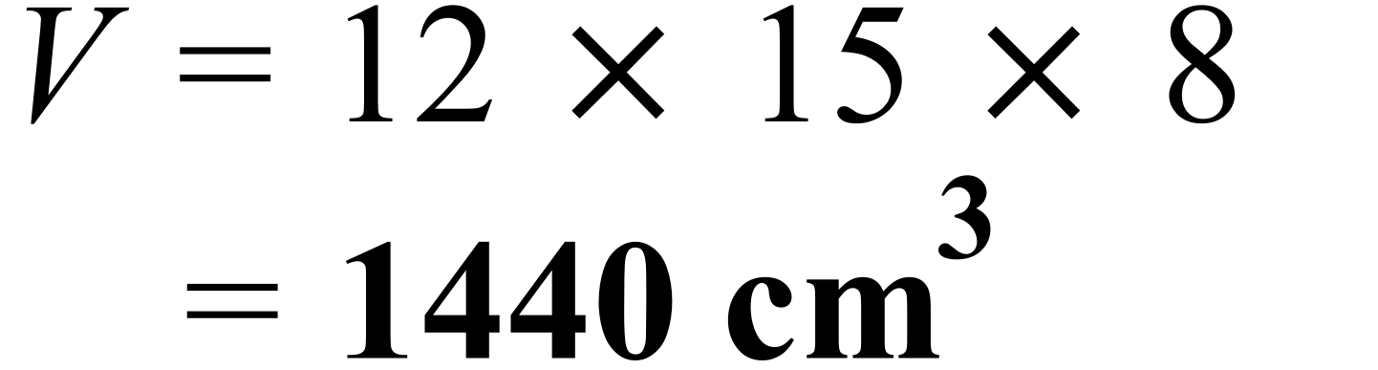
 | 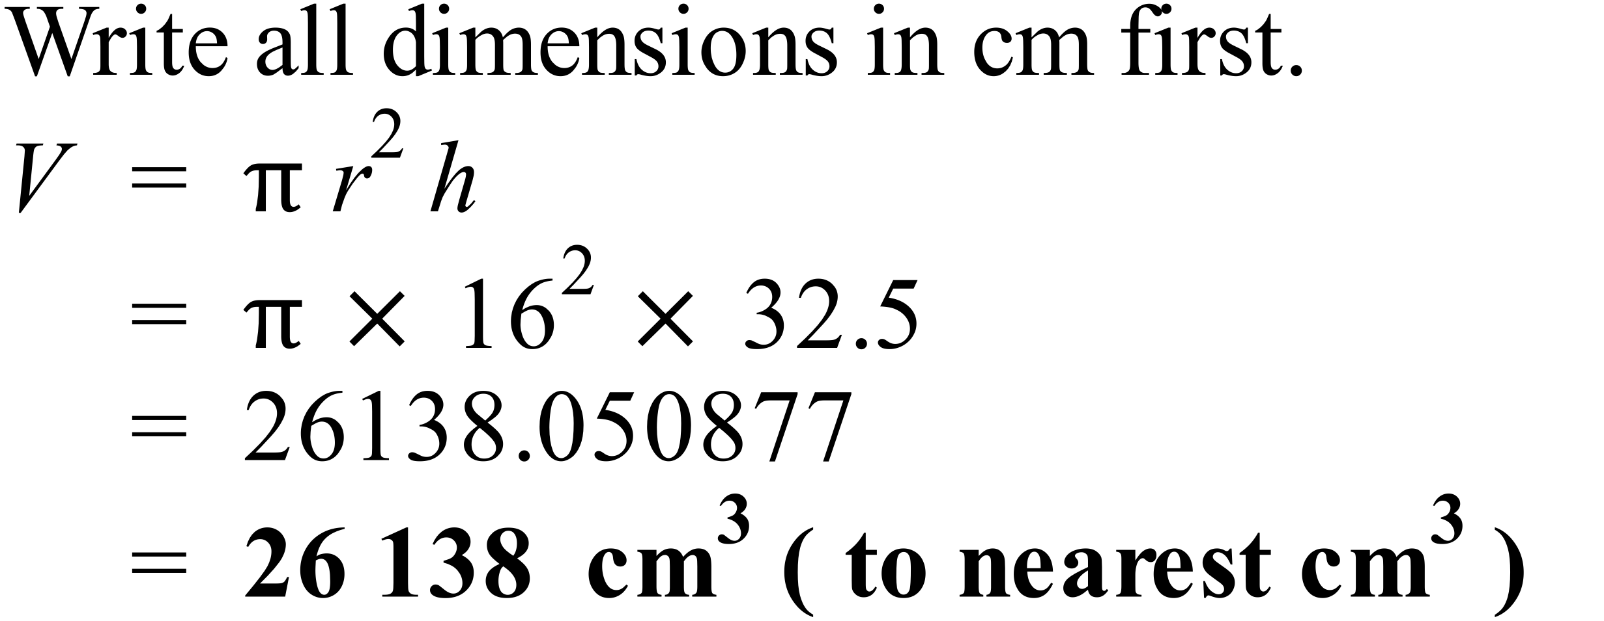
 | 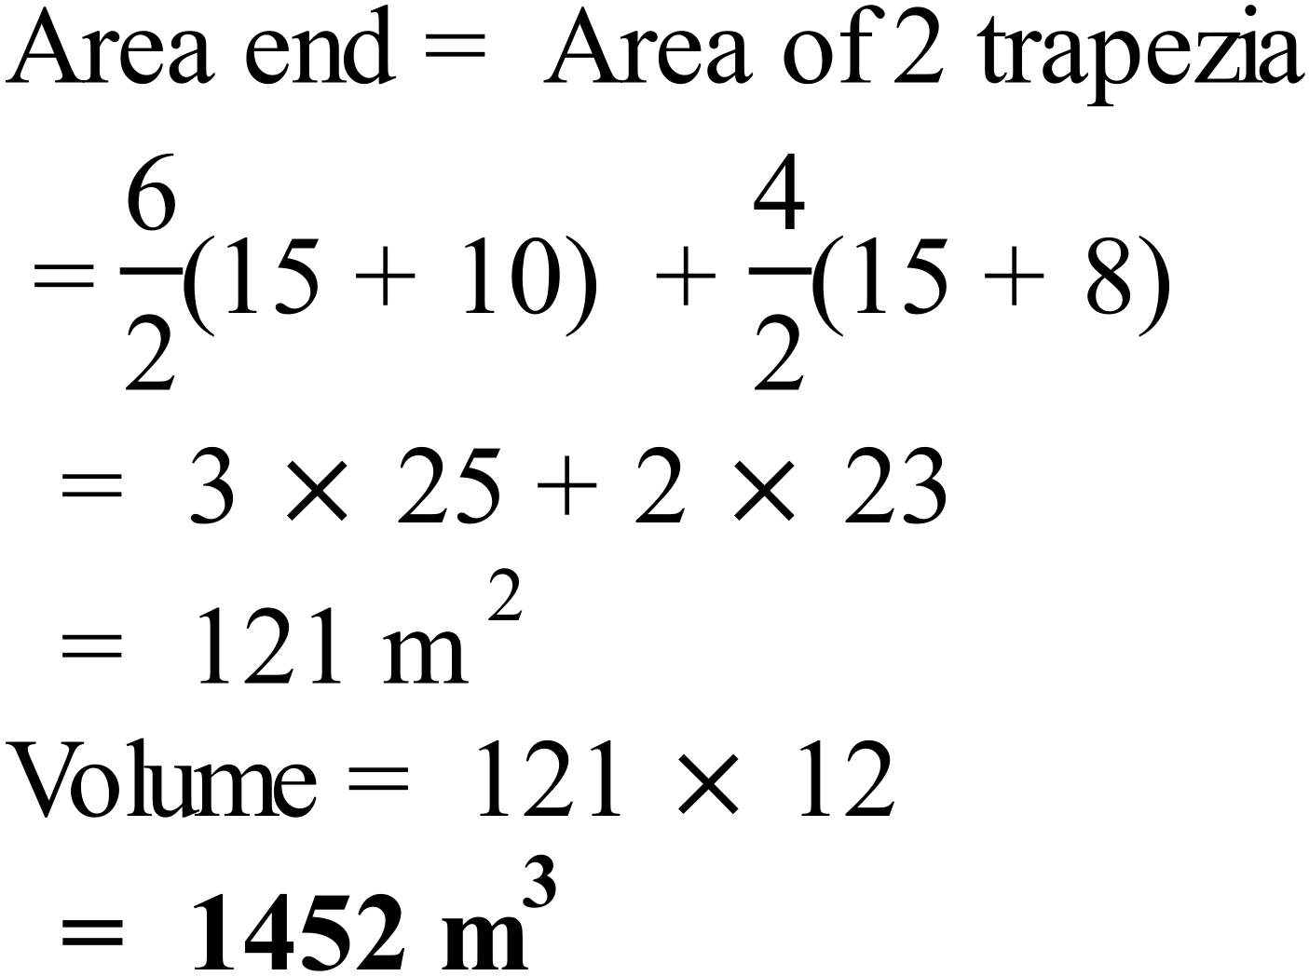
 | 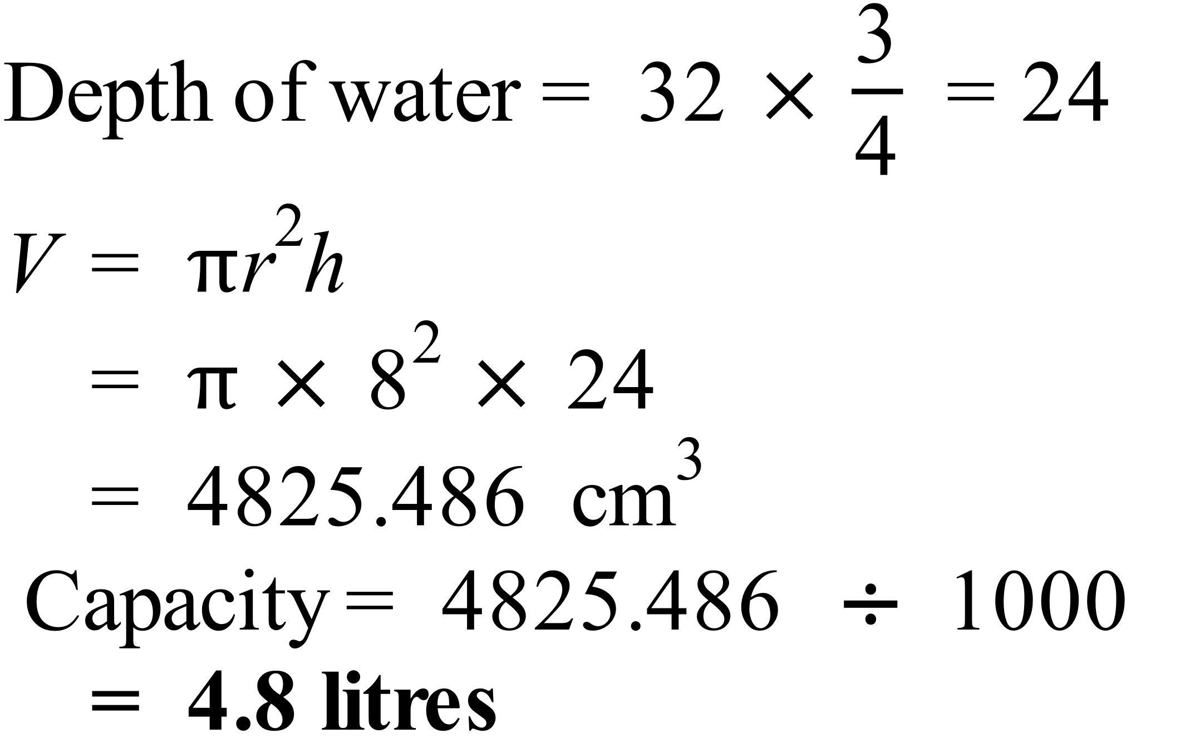
 | 